**Part 1 Result Screenshot**

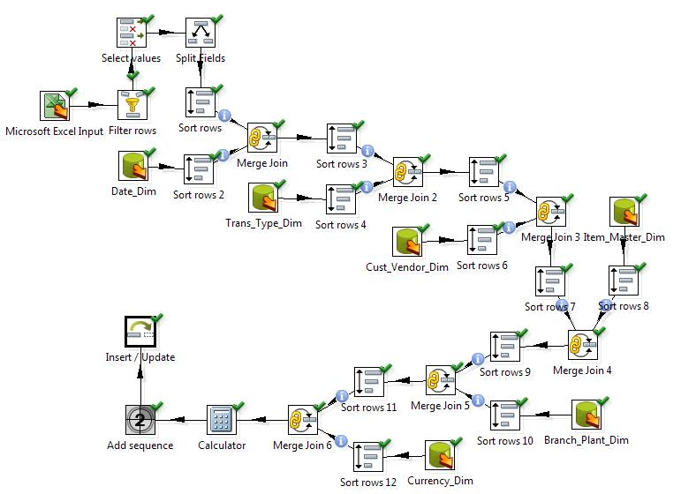

**Part 2 Result Screenshot**

